UCS configuration simple

To associate service profiles to servers.

First you need to define policies as below.

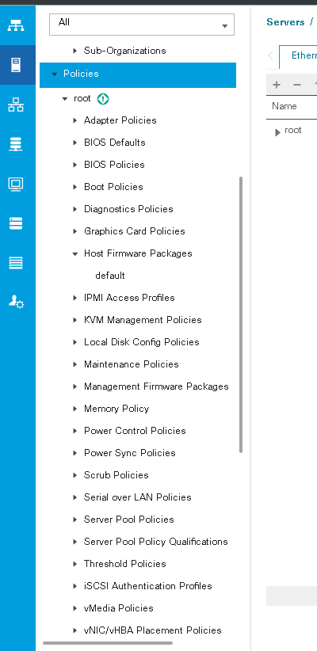

2 configuration: you need to create service profile template here you have to use policies just earlier you created

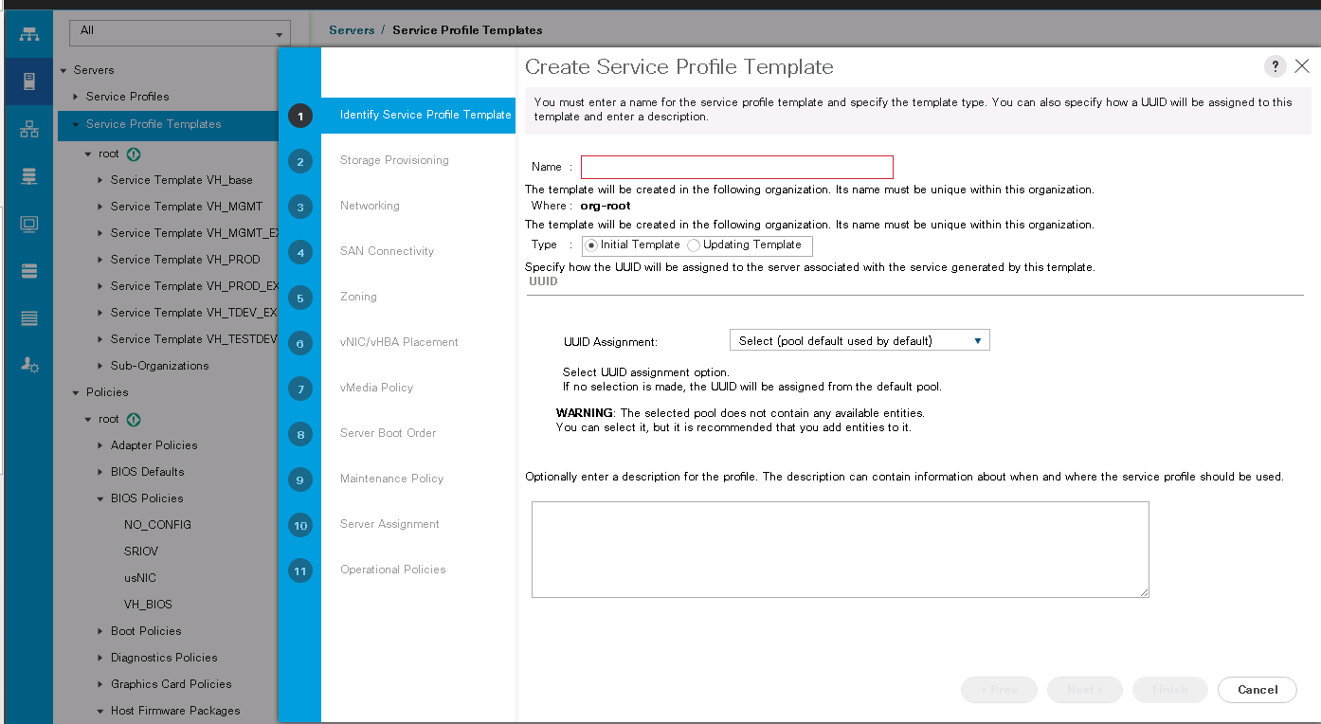

After you created service profile template it looks like below:

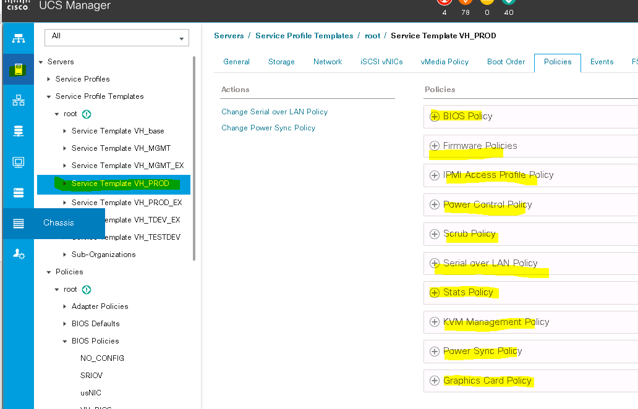

3) now you are good to create service profiles to associate service profiles to servers.

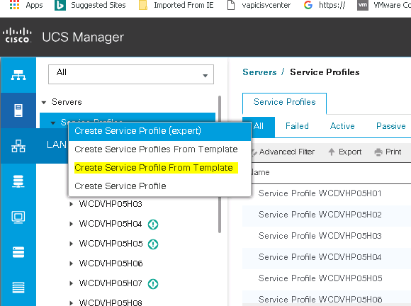

To create n no of service profiles at one go

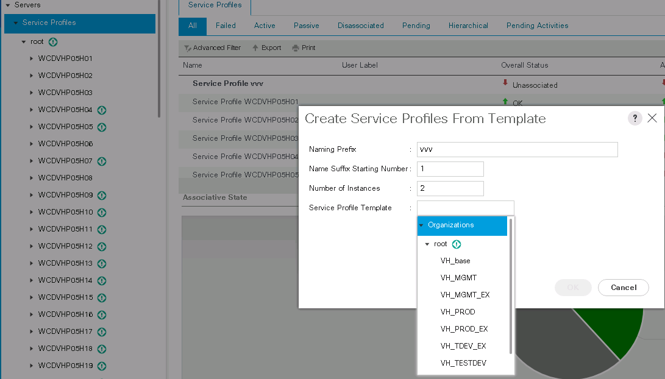

Single service profile

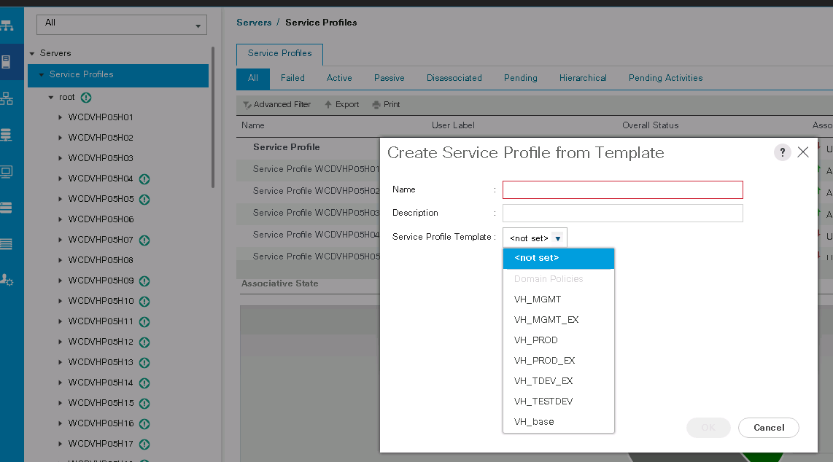

4) Once you are ready with service profile you are good to associate to blades.

Associate service profile, power on monitor from FSM tab, than MAP virtual dvd (ESXi) install ESXi

